**Exercise 1: Mocking and Stubbing**

**Scenario:** You need to test a service that depends on an external API. Use Mockito to mock the external API and stub its methods.

**STRUCTURE:**

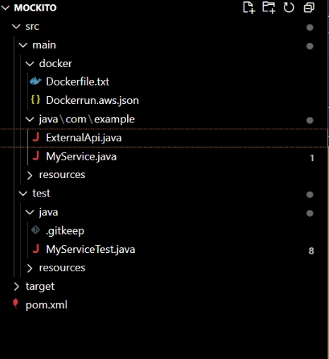

**CODE:**

ExternalApi.java:

package com.example;

public interface ExternalApi {

String getData();

}

MyService.java:

package com.example;

public class MyService {

private ExternalApi api;

public MyService(ExternalApi api) {

this.api = api;

}

public String fetchData() {

return api.getData();

}

}

MyServiceTest.java:

package com.example;

import org.junit.jupiter.api.Test;

import static org.mockito.Mockito.*;

import static org.junit.jupiter.api.Assertions.*;

public class MyServiceTest {

@Test

public void testExternalApi() {

// 1. Create mock

ExternalApi mockApi = mock(ExternalApi.class);

// 2. Stub behavior

when(mockApi.getData()).thenReturn("Mock Data");

// 3. Inject mock and test

MyService service = new MyService(mockApi);

String result = service.fetchData();

// 4. Assert result

assertEquals("Mock Data", result);

}

}

pom.xml:

<project xmlns="http://maven.apache.org/POM/4.0.0"

xmlns:xsi="http://www.w3.org/2001/XMLSchema-instance"

xsi:schemaLocation="http://maven.apache.org/POM/4.0.0 http://maven.apache.org/maven-v4_0_0.xsd">

<modelVersion>4.0.0</modelVersion>

<groupId>com.example</groupId>

<artifactId>myapp</artifactId>

<packaging>jar</packaging>

<version>1.0-SNAPSHOT</version>

<name>myapp</name>

<dependencies>

<!-- JUnit 4.13.2 for testing -->

<dependency>

<groupId>junit</groupId>

<artifactId>junit</artifactId>

<version>4.13.2</version>

<scope>test</scope>

</dependency>

<!-- Required for JUnit 4 -->

<dependency>

<groupId>org.hamcrest</groupId>

<artifactId>hamcrest-core</artifactId>

<version>1.3</version>

</dependency>

<!-- JUnit 5 -->

<dependency>

<groupId>org.junit.jupiter</groupId>

<artifactId>junit-jupiter</artifactId>

<version>5.10.0</version>

<scope>test</scope>

</dependency>

<!-- Mockito -->

<dependency>

<groupId>org.mockito</groupId>

<artifactId>mockito-core</artifactId>

<version>5.12.0</version>

<scope>test</scope>

</dependency>

</dependencies>

</project>

**OUTPUT:**

